Figure 2: Price differences* between identical presentations of the originator and generic and the prices of the generic medicine per unit for five molecules in 16 European countries, data as of November 2011
Gemcitabine, 1 1g powder for solution for infusion | Mypcophenolate mofetil, 100 caps 250 mg
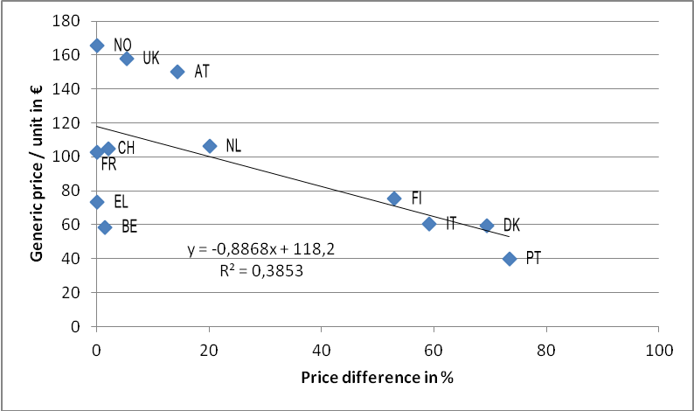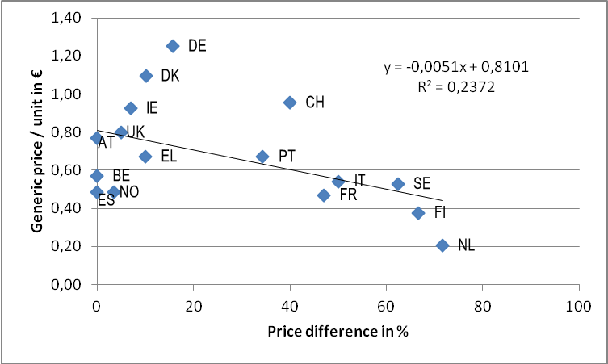
n =12  No price comparison possible in DE, ES, IE, SE due to missing generics in a comparable presentation  Olanzapine, 28 f/c tabs 10 mg | n =16  AT: different pack size and dosage (150 500mg f/c tabs), BE, CH, DK: 300 units, but same dosage and pharmaceutical form  Risperidone, 60 f/c tabs 4 mg
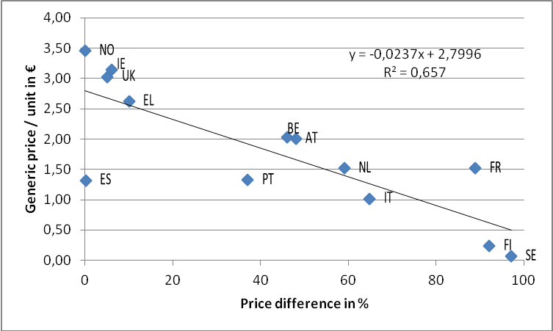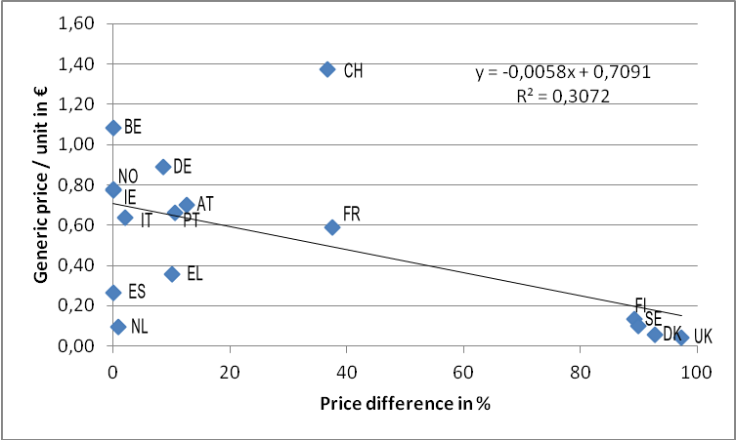
n =13  NL: data adjusted at unit level - 30 units/pack for original product, 28 units/pack for generic, NO: different pharmaceutical form: orodispersible tabs, SE: 56 units, same dosage and pharmaceutical form  Sumatriptan, 6 f/c tabs 50 g | n =16
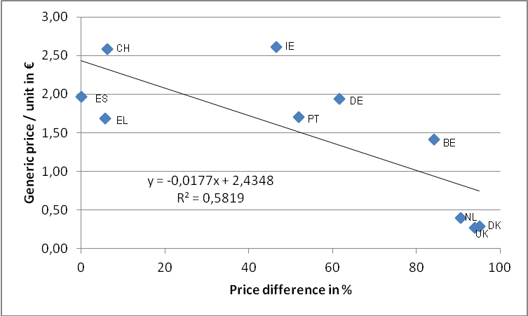
n =11
ES and EL - 4 units, PT - 2 units, same pack size and pharmaceutical form; BE - 100 mg f/c tabs
* expressed as the percentage which the price of the generic is lower than the one of the originator

