Atypical presentation of periodic paralysis: a case report

**Key Words**: Periodic Paralysis; Potassium; Muscle Weakness; Dizziness; Hypokalemia

# Abstract

Hypokalemic Periodic Paralysis (HPP) is a one kind of Periodic Paralysis which is a heterogeneous group of muscle disease. It is characterized by episodes of flaccid and sudden muscle weakness.

Here we present a case at first with a complaint of severe dizziness and fall. After comprehensive evaluation revealed a markedly low potassium. The patient’s complaining resolved after upon replation of his low potassium an he was discharged without deficits. An association with exercise, carbohydrate load and stress is well established and further work up revealed no association with some of this precipitants. HPP must differentiated from other causes of weakness and paralysis so that the proper treatment can be initiated rapidly.

|  |
| --- |
| **Why we describe this case**  Dizziness and weakness are common symptoms and may be caused by several illnesses. Hypokalemic Periodic Paralysis is a rare disease, but should be taken into consideration after a proper diagnostic workup |

# Introduction

Periodic paralysis is a heterogeneous group of inherited muscle disorders. It is characterized by recurrent attacks of intermittent skeletal muscle weakness. It is more commonly seen as episodic attacks. The common point of most of them is changes in anion channels and particularly in potassium channels [1].

# Case Description

A 42-year-old male with no significant past history presented to the emergency room with a sudden onset of severe dizziness and fall. Before that night when he fall asleep he had no dizziness or weakness. In that day he has awoke without dizziness or weakness. At noon time he had a mild dizziness which has been increased in 2 hours and he had fall at home as a result of suddenly onset muscle weakness. The dizziness was as motion of the environment and the weakness was bilateral and involved both the proximal muscles of the shoulders and hips as well as the distal extremities. He had no respiratory and swallowing difficulties and was able to move his neck and face muscles. He denied any pain or paresthesia. Prior to this condition, the patient may experience any newly developing diarrhea, chest pain, shortness of breath or weight loss. His parents and brothers had no history of similar episodes and no other significant illnesses.

On physical exam he was conscious, cooperated, arterial blood pressure was 130/80 mmHg, heart beat was 80/minute. He was on normal weight. His skin was cold and dry, and the oral mucosa was moist. No jugular venous distension, goiter or lymphadenopathy were appreciated. Cardiac exam revealed with normal heat rate with a regular rhythm and no murmurs. Examination of the lungs and abdomen were unremarkable. There was no deformity and edema in the extremities, distal pulses were bilateral and equal. At neurologic examination, his right and left upper extremity muscle strength was 1/5 and his right and left lower extremity muscle strength was 3/5. He had no nystagmus. Cranial nerve function was grossly intact

Routine chemistry, liver enzymes and complete blood count were normal except for a potassium level of 2,3 (3.5–5,1 mmol/l). Electrocardiogram revealed with features of hypokalemia (T wave inversion). Computed tomography of brain was performed to determine a etiology and was considered to be normal. The patient, who was thought to have more conversion disorder, was asked for neurological consultation for differential diagnosis.

Six hours after initiation potassium infusion (KCl [2 mEq/ml]) at 5 ml/h through a peripheral vein, the patient’s neurological symptoms had completely resolved. Further investigation were performed to elucidate the etiology of hypokalemia. Urine sodium and potassium, and serum aldosterone and renin levels were measured to rule out adrenal involvement and were found to be normal. Thyroid stimulating hormone was performed to be normal (Figure 1).

The patient was diagnosed with Hypokalemic Periodic Paralysis with unknown etiology and was started a potassium sparing diuretic. He was discharged home with an appointment to follow up with an endocrinologist.

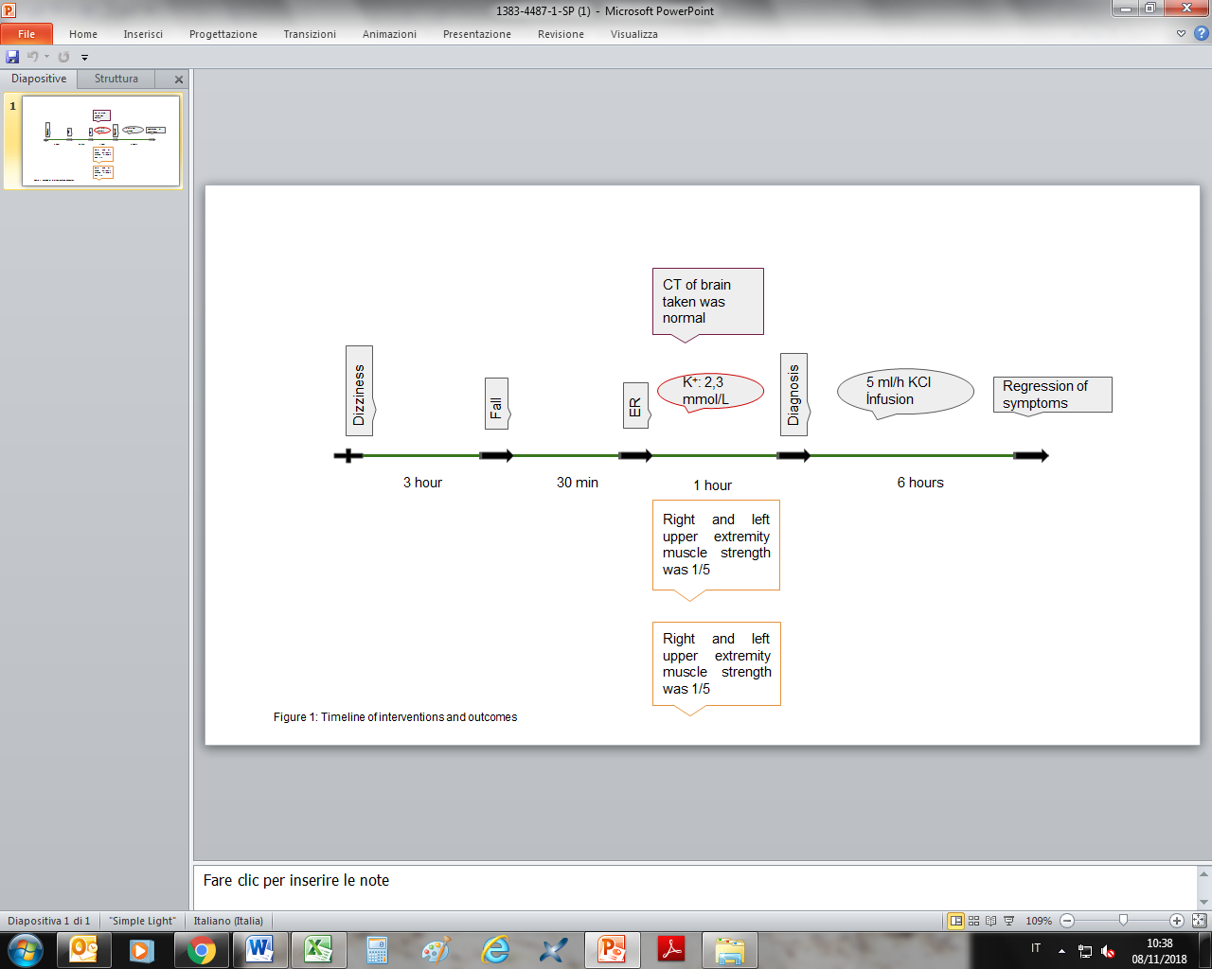

# Discussion

Dizziness is a nonspecific term often commonly used by patients to identify symptoms. Among this term the most common disorders are vertigo, nonspecific dizziness, disequilibrium, and presyncope. The first step in the evaluation is to match the patient with typical symptoms to one of these categories.

Weakness is a common, non-specific, presentation in both the emergency and outpatient setting. Although the differential diagnosis for dizziness and weakness is extensive. Strokes and tumors that cause nerve entrapment are potentially life-threatening and should be ignored first.

For the diagnosis of this disease, the duration and distribution of symptoms should be evaluated together with a detailed resume. HPP is often ignored during the first run.

The patient was diagnosed with hypokalemic periodic paralysis (HPP) whose prevalence rate was thought to be approximately 1:100,000 in further consideration [2]. HPP is a disorder affecting more commonly males with ages ranging between 20 and 40 years. The clinical features of the syndrome vary slightly depending on the underlying etiology. Although the serum potassium level is often alarmingly low, other electrolytes are usually normal [6]. In fact, the total body potassium is actually normal with the change in the serum level reflecting a shift of potassium into cells. Between paralytic attacks, muscle strength and potassium levels are normal so diagnosis at this period is difficult. Electrocardiographic changes are common, but differ from patients with true low potassium. Electromyography reveals abnormalities in some patients, but is usually normal between episodes when there is no clinically detectable weakness.

HPP may be due to various causes, so it may require extensive research to elucidate the underlying etiology. HPP may occur sporadically, which may occur as spontaneously or as the result of authosomal dominant inheritance. This form is felt as a deterioration of cellular potassium regulation due to abnormalities of sodium and calcium channels. Acute paralytic attacks are treated with potassium replacement, cardiac rhythm and serum potassium levels should be closely monitored.

Diagnostic criteria for primary hypokalemic periodic paralysis have been published by a Cochrane review. According to these criteria, this patient was consistent with the criterion characterized by recurrent attacks of muscle weakness with documented serum K <2.5 mEq/l. The patient was also consistent with the other three criteria of diagnostic criteria for hypokalemic periodic paralysis (HPP): Duration of paralysis longer than two hours, improvement in paralysis symptoms with potassium replacement and recurrence of symptoms under the certain periods and circumstances [3,4].

HPP can be triggered by the effect of factors such as alcohol, anesthesia, and excessive consumption of carbohydrate rich meal, stress, insulin, strenuous exercise, and steroids. Although it is too rare, it is considered that cold or overtemp can also induce paralysis at regular intervals, but there is not adequate data. In general, after exclusion of the other causes, the main treatment is potassium replacement. The remaining supportive treatment is correction or avoidance of the other triggering factors. Hypokalemia occurs before the clinical presentation, therefore, precautions can be taken with previous close follow-up. It should be preferred to administer normal saline (0.9%) and but dextrose containing solutions should be avoided during fluid replacement.

The symptoms such as sweating, myalgia, mental dullness, irritability, and palpitations also occur rather than muscle weakness during the attacks [5].

Previously reported case of HPP in the literature is at children [7] and most of this cases are associated with thyrotoxicosis [8].

This case was not completely consistent with the other patients with regards to age and triggering factors, but he was considered to be HPP after exclusion of differential diagnosis and in consequence of treatment performed. Although the patient was planned to be discharged upon obtaining a potassium level of 3.5 mmol/l, a K+ rich and Na+ poor diet was planned for long-term since he experienced the second attack. The patient was informed regarding the triggering and alarming symptoms.

It should be kept in mind that even though age and triggering factors do not always overlap, HPP should be considered.

|  |
| --- |
| **Key points**   * Dizziness and weakness are common symptoms * Hypokalemic Periodic Paralysis (HPP) is characterized by episodes of flaccid and sudden muscle weakness * Generally, it affects males with ages ranging between 20 and 40 years * Serum potassium level is often alarmingly low, but other electrolytes are usually normal * Acute paralytic attacks are treated with potassium replacement * Cardiac rhythm and serum potassium levels should be closely monitored * HPP may be due to various causes, so it may require extensive research to elucidate the underlying etiology * Among the triggering factors, there are alcohol, anesthesia, and excessive consumption of carbohydrate rich meal, stress, insulin, strenuous exercise, and steroids |

# References

1. Zacchia M, Abategiovanni ML, Stratigis S, Capasso G. Potassium: From Physiology to Clinical Implications. Kidney Dis (Basel). 2016 Jun. 2 (2):72-9.
2. [Abbas](https://www.ncbi.nlm.nih.gov/pubmed/?term=Abbas%20H%5BAuthor%5D&cauthor=true&cauthor_uid=23833504) H, [Kothari](https://www.ncbi.nlm.nih.gov/pubmed/?term=Kothari%20N%5BAuthor%5D&cauthor=true&cauthor_uid=23833504) N, [Bogra](https://www.ncbi.nlm.nih.gov/pubmed/?term=Bogra%20J%5BAuthor%5D&cauthor=true&cauthor_uid=23833504) J.Hypokalemic periodic paralysis.[Natl J Maxillofac Surg](https://www.ncbi.nlm.nih.gov/pmc/articles/PMC3700163/). 2012 Jul-Dec; 3(2): 220–221.
3. Vicart S, Sternberg D, Arzel-Hézode M, et al. Hypokalemic Periodic Paralysis. 2002 Apr 30 [Updated 2014 Jul 31]. In: Adam MP, Ardinger HH, Pagon RA, et al., editors. GeneReviews® [Internet]. Seattle (WA): University of Washington, Seattle; 1993-2018.
4. Sansone V, Meola G, Links TP, Panzeri M, Rose MR. Treatment for periodic paralysis. Cochrane Database Syst Rev. 2008;(1):CD005045
5. Frey K, Holman S, Mikat-Stevens M, Vazquez J, White L, Pedicini E, et al. The recovery profile of hyperbaric spinal anesthesia with lidocaine, tetracaine, and bupivacaine. Reg Anesth Pain Med. 1998;23:159–63.
6. Lin SH, Lin YF, Chen DT, Chu P, Hsu CW, Halperin ML. Laboratory tests to determine the cause of hypokalemia and paralysis. Arch Intern Med. 2004;164:1561–1566. doi: 10.1001/archinte.164.14.1561.

#### Gorostidi, A. Mosquera et al. P114 – 2576: Hypokalemic periodic paralysis: A case report based on clinical and genetic findings. European Journal of Paediatric Neurology , Volume 19 , S126

1. Kelley DE., Gharib H. , Kennedy FP, Duda RJ,Jr. McManis PG.Thyrotoxic periodic paralysis. Report of 10 cases and review of electromyographic findings.Arch Intern Med. 1989 Nov; 149(11): 2597–2600.
2. Soule BR, Simone NL. Hypokalemic Periodic Paralysis: a case report and review of the literature. Cases J. 2008;1(1):256. Published 2008 Oct 21. doi:10.1186/1757-1626-1-256