Clinical Management Issues July 30, 2026

Dear members of the Editorial Board,

please find enclosed our manuscript “Non-traumatic coma reversible by dialysis in a 67-year old patient with acute kidney injury” which we would like you to consider as a case report in the Clinical Management Issues.

Currently, there is no consensus about the treatment of baclofen intoxication. We report a 67-year-old patient with baclofen intoxication caused by acute kidney failure presenting in a deeply comatose state that could be completely reversed within hours after one single haemodialysis, assuming that drug elimination was increased with haemodialysis and recovery thus accelerated.

This manuscript has already been submitted to your journal, but unfortunately rejected. Thus, we have revised the manuscript carefully and generated a much shorter version of this case report. We hope, that this version will now be considered for publication again. Both the old and new version have not been published elsewhere. All of the authors have contributed to and approved of the final manuscript, none has any conflict of interest.

Sincerely yours,
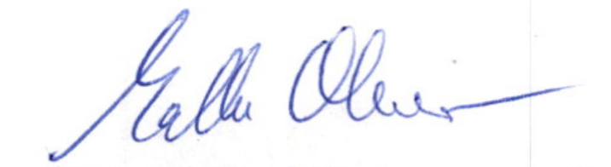

Oliver Malle, MD, corresponding author

Medical University Graz
Department of Internal Medicine
Division of Endocrinology and Diabetology
Auenbruggerplatz 15
Austria, A-8036 Graz
Phone: +43-316-385-31013
Fax : +43-316-385-13428
Email: oliver.malle@medunigraz.at

Title:
Non-traumatic coma reversible by dialysis in a 67-year old patient with acute kidney injury

Author details:
Malle O.¹, Urbanic-Purkart T.², Amrein K³.

¹ Malle Oliver, Medical University of Graz, Department of Endocrinology, Graz, Austria
² Urbanic Purkart Tadeja, Medical University of Graz, Department of Neurology, Graz, Austria
³ Amrein Karin, Medical University of Graz, Department of Neurology, Graz, Austria

Ethics approval
Not applicable.

Competing interests
All authors (Malle O, Urbanic Purkart T and Amrein K) declare that they have no competing interests

Funding
Not applicable. No funding to declare.

Acknowloedgements
Not applicable.

